# MRD: MBACAS

Date last updated: 10/22/2014

## Vision

Our product MBACAS ( Master of Business Administration Centralized Application Solution) is a single portal for prospective MBA applicants who apply to multiple MBA programs, and a solution for MBA admission teams to enable efficient planning and implementation of the admission process. The positioning statements, mentioned below, for our two set of customers explains the vision, soul and uniqueness of our product:

**MBA applicants**

For **“prospective MBA students”**

Who are **“facing hassles of applying to multiple Business schools and of managing multiple online applications”**

Our **“MBA Centralized Application Solution is an application management portal”**

That provides **“MBA students with a single portal to create, submit and track applications for multiple schools”**

Unlike **“existing 3rd party software”**

We offeran **“amazing user experience, synchronized time line for all application tracking and provide customized recommendations to enable smooth and intelligent application process.”**

**B-School admissions team**

For **“US B-School admission teams”**

Who **“evaluate hundreds of applications every year”**

Our **“MBA Centralized Application Solution is a software application”**

That provides **the “admissions team with a great tool to collaborate while evaluating applications, interact with applicants during the application process, plan their admissions marketing strategy, and predict their admission cycle.”**

Unlike **“existing solutions,”**

We offer an  **“amazing user experience and data analytics to enable better planning and productivity.”**

## Motivation

### Unmet Needs

After researching articles about the MBA application process and conducting student surveys, we believe the most important unmet needs are as below:

* **Unavailability of one-stop solution for all MBA applications:**

One of the biggest pain points among the MBA applicants is the time consumption due to filling out the same basic background information for each and every school again and again. As per our survey of 100 MBA applicants, 50% of our survey respondents admitted that they spent on average more than 1 hour in setting up the profile on the application portal for a business school. When we asked about the number of business schools they had applied to, 77% responded that they had applied to at least two schools and 27% of the respondents applied to more than 5 schools. When asked about the ease of obtaining multiple recommendations from the same recommender, 43 students rated the process as 3.72 out of 5 on average and 5 representing very difficult. This clearly shows the needs to have a centralized application portal, which could save time for MBA applicants and improve their application experience.

* **Track the real time progress of an application:**

Most of MBA applicants admit that applying for B-schools is a full-time job. It involves constantly checking on all the applied business school websites for updates, tracking all deadlines and inquiring about the progress of your application over and over. After surveying MBA applicants, one of the top feedback we received was being able to get real time updates regarding deadlines, recommendation requests and progress of their application.

* **Single log-in or having one credential rather than multiple ones:**

Each MBA applicant submitted, on average, 3 applications according to the Graduate Management Admissions Council. As per our survey, 35 applicants had responded that they had forgotten their login credential more than 3 times during their application process. This leads us to conclude that a single sign on solution would add lot of value in improving the MBA application process.

* **One channel to reach out to all schools for queries during application:**

MBA application process is a tedious process which involves filling out multiple forms which, at times, could be intimidating if the requirements for each schools are not clear. This often leads to students wanting to get in touch with the admissions office at various schools. From our survey, one of the top recommendations provided by students was having a single channel to communicate with all schools so that they could get their queries resolved faster.

* **Data analytics engine that could provide schools as well as students with trends and statistics so that they could make informed decisions:**

With the evolution of technology, data analytics has been a vital resource in better decision making. Companies use data analytics engine to draw correlations, trends and recommendations for their business. There has been an increase in the number of business school applications over the years. Students and the business schools could greatly benefit if all application data could be pooled into a central data analytics engine which could provide statistics and recommendations to both students and business schools.

### Customer Segments

On a high level, we have two target segments as below.

* US Business schools
* All MBA Applicants

**US Business schools:**

US MBA schools are our primary target segment. The early adopters in this segment would be schools which receive many applications and are open to use of third party technologies to simplify the application process. As per Poets and Quants[1], Harvard Business School, Stanford and Wharton are the top 3 business schools that received the most number of applications in 2013. According to the Director of Admissions we interviewed at the University of Washington, he mentioned that Stanford is known to be one of the first to adopt third party solutions. Hence our strategy would be to target the top 25 business schools whose adoption would eventually influence other business schools to start using MBACAS. We would be using the push and pull strategy where in we would pull the top 25 business school to adapt our solution. The adapted school would eventually push the use of the MBACAS portal to all MBA applications.

**MBA Applicants:**

Amongst MBA applicants, MBACAS would be most beneficial to those that apply to more than 3 business schools. It takes a great deal of time to create a profile for each business school and to keep track of the progress via the different application portals. As per our survey, close to 70% of the applicants showed their concern on time utilized on filling out same data on multiple forms. They also voiced their hesitation for not being able to approach the same recommender for recommendations when they had applied to more than 3 business schools. The MBA Centralized Application Solution would solve most problems faced by the applicants and improve their application experience.

On a demographics scale, we believe MBA applicants who have more than 5 years of industry experience would be already busy with their professional life. This group would be our product advocates since it would save a great deal of time and have a better tracking mechanism for their applications.

Please see **Appendix 1** for a summary of all results obtained from surveying current and past MBA applicants.

### Existing Solutions :

### Existing School-owned portals :

Currently, some business schools use their own graduate school application portals to receive and manage MBA applications. We interviewed the Director of Admissions at the University of Washington and he admitted that the grad school application portal, although it is free to use for the MBA school, does not have the customization and functionality required for the MBA application process. He stated that B-schools would be willing to switch to a new system if it can save time and meet their needs.

1. **GMAC (Graduate Management Admission Council):**

GMAC offers trends and statistics data for business school and MBA applicants. It uses the GMAT exam data to provide information such as demand for graduate management education, current GMAT volume and profile of GMAT candidates. However, GMAC does not provide a solution to ease the rigorous process of applying to business schools.

1. **Best MBA :**

Best MBA website is an online directory for finding best MBA programs in the world. The online directory provides ranking of the world's best MBA programs in each region and other reputable MBA programs in each country including the university/institute's address, telephone contact number, the city or cities in which the MBA program runs, the length of the MBA program with start dates, the country and the course format. Best MBA can only help applicants find the best business schools, but it does not aid in the application process or facilitate communication with schools.

1. **ApplyYourself (Hobsons) :**

ApplyYourself is a third party application management system owned by Hobson. ApplyYourself works with each school, who is the customer, to help them receive and review applications, however, each school has a separate portal. Students who apply to schools that use ApplyYourself still have to create separate profiles and log-ins for each school and re-enter and submit all application materials separately. This system is not a centralized application solution; it is an application management system.

### Differentiation

The benefits of using a centralized application portal are multifold. It not only makes the application process simple and easy to track but with more data being fed to the centralized system, we are able to provide better information to students as well as school so that they can make an informed decision. We are also able to make recommendations based on historical data, which increases the overall performance of the students and schools.

We will provide a service similar to existing solutions, however, our product will seamlessly integrate the best of these solutions into one portal. Our system will also provide schools with the flexibility to create their own customized application requirements and allow them to communicate with applicants.

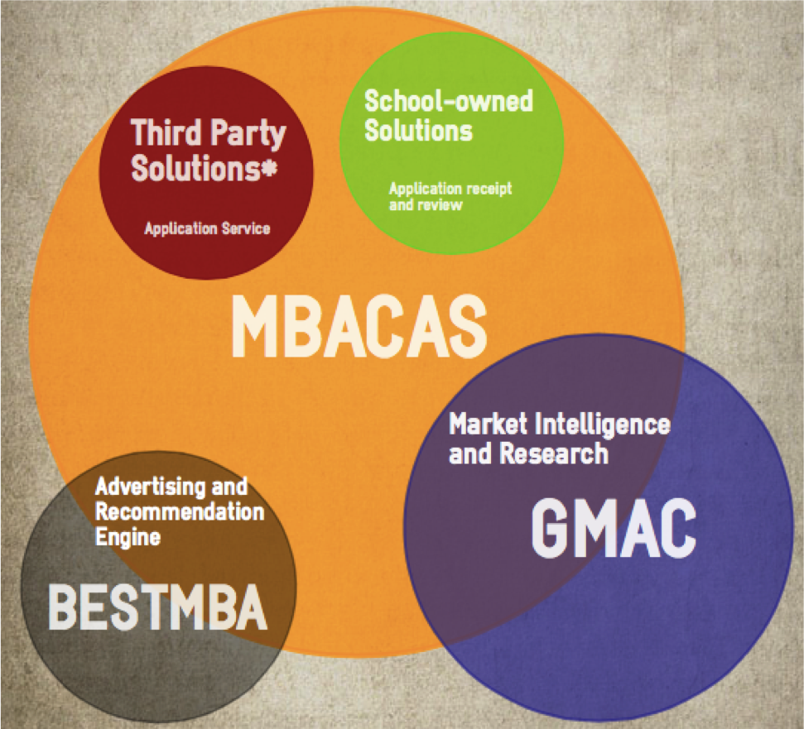

*Hobsons

### 

### Why Now?

With the number of business school applications increasing year over year, MBACAS would be the ideal solution to improve the overall experience of students and also providing business schools with statistical data for improvements.

## Use Cases

### Applicants:

1. **A prospective applicant has just decided to apply for US MBA program. She is not sure where to start.**

* She creates a profile at MBACAS.
* Enters preliminary information about herself.
* Clicks on “explore schools” and MBACAS helps her find the right school.
* Finds a search box and below that a list of all the B-school programs
* Clicks on few filters to fine tune her search.
* Clicks on the various schools and analyzes past trend of average GMAT scores, class size and applicant profiles.
* She has an option to “apply” or “add to dreamlist” for that specific school.

1. **A prospective student who is in the process of applying to MBA programs.**

* She creates a profile at MBACAS (if she doesn’t already have one).
* Enters basic information about herself.
* Selects schools she wants to apply to.
* MBACAS guides her through the application process for each school and helps her keep track of deadlines and her application progress.

1. **A prospective student wants to check the status of her application after she has applied.**

* She logs into the MBACAS and finds her personal dashboard.
* She has a list of the B-School programs, where she has applied, with present status for each B-School program.
* The status values are hyperlinks, which takes her to:

a. Interview scheduling tool if the status is “interview request”

b. Admit letter if the status is “admitted”

c. Reject letter if the status is “reject”

d. Special information page if the status is “additional information required”

e. Application if the status is “In-Review”

### B-School admissions team

1. **An admission committee member finalizes the requirements in terms of application material for a given admission cycle.**

* She logs into her admin account page and selects the fields she wants on the application page for the school.
* She enters the deadline for various rounds, essay questions for the applicants and other custom fields if required.
* She previews the page and also does a trial run for the whole process.
* She edits the required information and/or publishes it.

1. **An admission committee member who is evaluating applications for a particular round.**

* She logs into the system and finds her dashboard.
* Clicks on “applications submitted” and finds all the applicant names as hyperlinks.
* She can either filter the list or search a particular student by name or application number.
* She clicks on a particular applicant name and finds his/her page and is able to view the application materials on-line. She can add comments and/or highlight sections of the application. The comments can be shared with other admission committee members and multiple admissions committee members can collaborate on any application.

1. **Admission committee has decided to send interview invites for a particular round.**

* She logs into her account, finds her dashboard and then clicks on “admin page”.
* Selects all applicants, selected for interviews, and selects open interview slots for them.
* Shares the interview slots to students by interview scheduling tool.

## Market Size

“For the 2013–2014 academic year, 50% of *full-time two-year MBA* programs reported increased application volume” according to a survey done by GMAC. “Survey responses were contributed by admissions professionals at 683 graduate management programs from 328 business schools and faculties around the globe.”

In testing year 2012–13, a total of 238,356 GMAT exams were administered, with 675,733 score reports sent to nearly 5,600 graduate-level management programs around the world.[2] The country with the most test takers were China and India.

On average 476 MBA programs receive a total of 196,032 completed applications per year. The number of applications per program varied greatly, ranging from fewer than 10 to nearly 10,000. The top 50 MBA schools, receive a median of 1,554 applications. Schools in the second-tier, the next 50, got less than a third of that, 405 applications per program, while all the remaining schools had a median of 147 applicants.[3]

The average GMAT test taker submits score reports to 2.9 schools, according to the Graduate Management Admission Council.[4] However, “new research suggests that for many B-school applicants the number is far higher. More than 48 percent of the 652 respondents to a recent survey said they either applied or were planning to apply to five or more graduate business schools...Survey showed that 21 percent of respondents applied to five business schools, 14.5 percent applied to six, 4.5 percent applied to seven, and 8.3 percent applied to eight or more.”

## Caveats / Risks / Key Dependencies

1. Privacy concerns - both students and B-schools would be concerned about who has access to their data and the use of this data.
2. Legal concerns - we want to make sure we are not violating any laws regarding the storing and “usage” of private personal data submitted to our application portal.
3. Access and downtime concerns - we are aware that students and B-school users may be concerned about server crashes and not being able to access their applications in a timely manner.
4. B-Schools may be hesitant to adopt a different technology when they have a currently solution that works well for them.
5. Cost - we are unsure about the cost of implementing MBACAS. We are looking to partner with agencies that perform background checks and identity verification.
6. Most MBA schools are governed by the University Graduate School and may not have control over the type of application system they use. There may be push back from decision makers that are not part of the MBA admissions committee.
7. GMAC push back - we are aware that there is a possibility that GMAC will not “endorse” us. They may feel threatened because we are providing the market data that they also provide to B-schools.
8. During our interview with the admissions committee at the University of Washington, we discovered that there was once a “centralized application system” called EMBARK that was available, however, this company is no longer in business. A reason that this company failed may be due high operating costs. We know that they charged $30,000 per year to the UW to provide this application service, however, this amount was not enough to keep this company in business. We might be facing similar risk if we do not have a good monetization strategy or we cannot get enough adopters.

## Competitive/Strategic Considerations

We are aware that GMAC or ApplyYourself have a capabilities to offer a centralized application system, however, we are not sure why this has not been accomplished. Each of these entities may have different objectives, therefore, may not be looking to provide our proposed solution right now.

We plan to start piloting our system with small regional schools to test our hypotheses before approaching large/high ranking schools. Our primary strategy would be to target the top 25 business schools whose adoption would eventually influence other business schools to start using MBACAS. We would be using the push and pull strategy where in we would pull the top 25 business school to adapt our solution. The adapted school would eventually push the use of the MBACAS portal to all MBA applications.

## Go/No Go Recommendation

Based on all the information provided and the data we collected from interviews and surveys, Our team is recommending a **GO!** There is definitely an unmet need regarding this service and the market size supports our plan.

**Appendix 1: Applicant Survey Results**

Out of 100 survey respondents, 77% applied to at least two schools and 27% of the respondents applied to more than 5 schools.

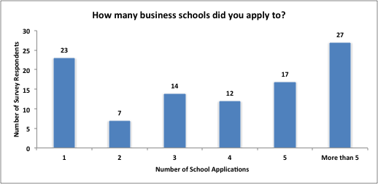

50% of our survey respondents admitted that they spent on average more than 1 hour in setting up the profile on the application portal for a business school.

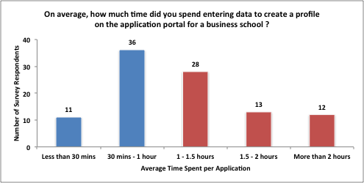

When we asked our customer segment of MBA students, we found that most of the students felt obtaining multiple recommendations from the same recommender, entering background information for multiple schools and managing multiple login credentials are difficult.

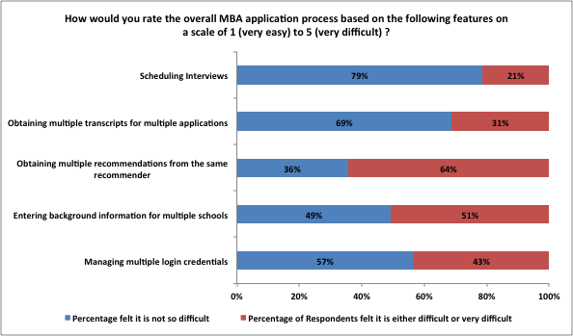

On scale of 1(very easy) to 5 (very difficult), here is the average of all responses.

|  |  |  |  |  |  |
| --- | --- | --- | --- | --- | --- |
| **Features** | **Managing multiple login credentials** | **Entering background information for multiple schools** | **Obtaining multiple recommendations from the same recommender** | **Obtaining multiple transcripts for multiple applications** | **Scheduling Interviews** |
| **Average Difficulty Level** | 3.12 | 3.51 | 3.66 | 2.65 | 2.69 |

24% of those who submitted application to more than one school responded that they missed the application deadline at least once during the process. At the same time, 73% of them agreed on forgetting their login details more than once while applying to the business schools.

Some of the common concern about the current MBA application process across the survey respondents:

*“I felt there were many questions on the application form that were* ***repetitive*** *and I had to enter* ***several times****”*

*“Greater transparency by the schools of what they are looking for.* ***One unique*** *application process for all schools would be very beneficial. “*

*“****Standardize*** *application costs amongst programs”*

*“I really didn't like inviting senior managers to type down their recommendation* ***several times*** *for me. Hope this could be improved.”*

*“A* ***one stop shop*** *for all schools would have been great--huge time saver”*

*“leverage* ***same background*** *and work experience data across different application”*

*“****Standardization*** *across MBA programs.”*

*“A* ***common platform*** *from where data can be pulled and automatically populated into the application”*

*“Develop a tool for retaining all possible data in* ***one time****, and then can be automatically feed into different format by different school.”*

*“It would be fantastic if there were a "Linkedin" type profile that could be* ***homogeneously*** *applied across multiple MBA programs.”*

*“It would be great to have* ***one portal*** *that manages all MBA applications with nuances for particular schools.”*

*“have* ***one website*** *that will fill out the applications automatically”*

*“****One application*** *for many schools (universal app)”*

*“****Standardize*** *the stuff that isn't integral to determining fit.”*

*“Automatically import* ***standard information*** *somehow such as address, education, job history.”*

1. http://www.usnews.com/education/best-graduate-schools/top-business-schools/slideshows/mba-programs-that-receive-the-most-full-time-applications/11
2. Profile of GMAT® Candidates, 2008–09 to 2012–13 (Executive Summary). 2013 Graduate Management Admission Council® (GMAC®)

  
3. http://poetsandquants.com/2010/08/26/b-schools-with-the-most-applicants/
4. http://www.businessweek.com/articles/2012-03-06/how-many-mba-applications-is-too-many